Web Development Assignment Answers

1. Difference between Frontend, Backend, and Full-Stack Development
Frontend: Builds the user interface using HTML, CSS, and JavaScript. Example: Amazon product page.
Backend: Handles server logic, authentication, and database operations using languages like Java, Python, or Node.js. Example: Processing an online payment.
Full-Stack: Develops both frontend and backend. Example: Building a complete e-commerce website.

2. Client-Server Model Diagram
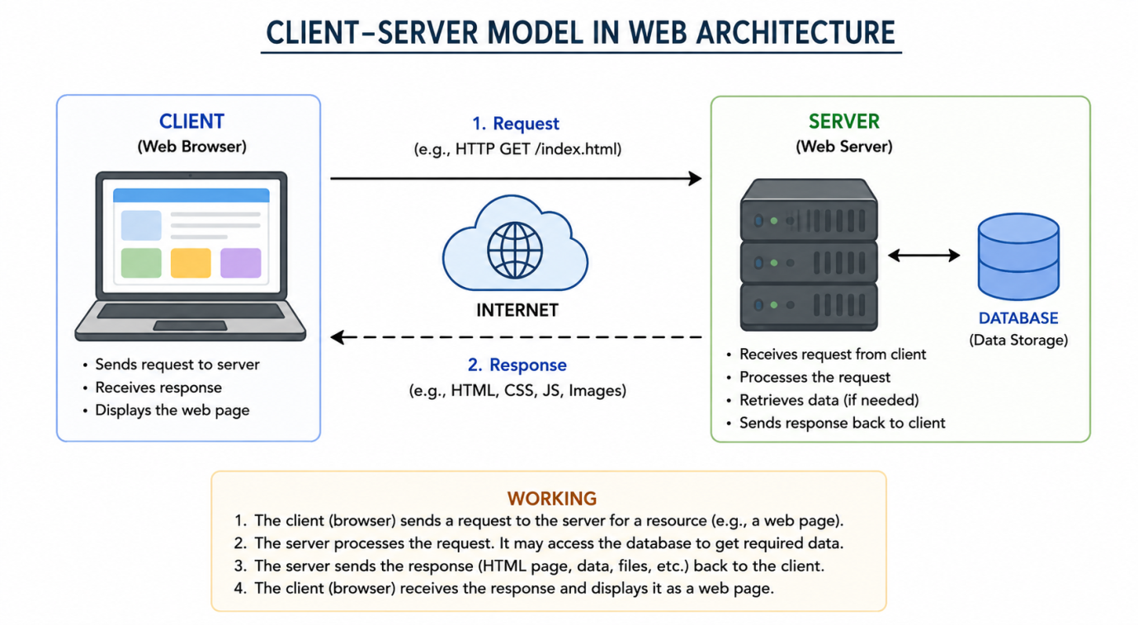

3. How a Browser Requests and Displays a Web Page
1. User enters a URL.
2. Browser sends an HTTP request to the server.
3. Server processes the request and fetches data if needed.
4. Server returns HTML, CSS, and JavaScript.
5. Browser renders the page for the user.

4. Tools Required for Web Development
• VS Code – Code editor.
• Web Browser – Test webpages.
• Node.js – JavaScript runtime.
• Git – Version control.
• Live Server Extension – Live preview.
• Chrome DevTools – Debugging.

5. What is a Web Server?
A web server stores and delivers web pages to users through HTTP/HTTPS.
Examples: Apache HTTP Server, Nginx, Microsoft IIS, Node.js Express.

6. Roles in a Project
Frontend Developer: Designs user interface.
Backend Developer: Develops server-side logic and APIs.
Database Administrator (DBA): Manages databases, security, backups, and performance.

7. VS Code Installation
Install VS Code, then install these extensions:
• Live Server
• HTML CSS Support
• JavaScript (ES6) snippets
Configure by creating HTML, CSS, and JS files and opening them with Live Server.
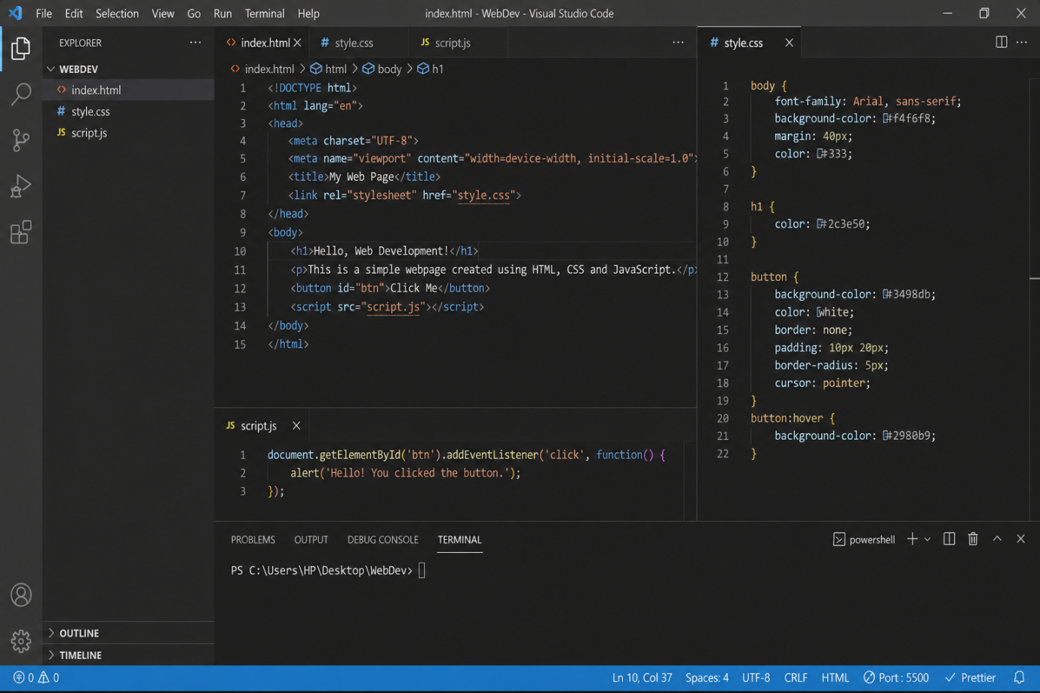

8. Static vs Dynamic Websites
Static Website: Fixed content. Example: Portfolio website.
Dynamic Website: Content changes based on user interaction or database. Example: Facebook or Amazon.

9. Five Web Browsers and Rendering Engines
Google Chrome – Blink
Microsoft Edge – Blink
Mozilla Firefox – Gecko
Safari – WebKit
Opera – Blink
Blink: Fast and Chromium-based.
Gecko: Mozilla's independent engine.
WebKit: Apple's rendering engine optimized for Safari.

10. Basic Web Architecture Diagram
